FLOOD MONITORING AND EARLY WARNING SYSTEM
FOR LOWER ANTIPOLO

A Capstone Project
Presented to
the Faculty of College of Computer Studies
University of Rizal System
Binangonan, Rizal

In Partial Fulfillment
of the Requirements for the Degree
Bachelor of Science in Information Technology

KENNETH Q. LOPEZ
EMIL O. CARLOTO
MYLENE H. ILAGAN
MEAGAN NICOLE C. MESA
KIERVY O. VIDAD

November 2026

TABLE OF CONTENTS
Preliminaries Page
TABLE OF CONTENTS ii
LIST OF FIGURES iv
LIST OF TABLES v

Chapters
1 THE BACKGROUND OF THE PROJECT 1
Introduction 1
Objectives of the Project 2
Scope and Limitation of the Project 3
Significance of the Project 5
Definition of Terms 5
2 REVIEW OF RELATED LITERATURES AND STUDIES 10
Flood Monitoring System (Sensors & Hardware) 10
Machine Learning and Flood Forecasting 13
Alert, Siren, and Warning Dissemination 17
Dashboard, System Architecture, and IoT Paradigm 21
Synthesis Table 23
Research Gap 28
3 METHODOLOGY 31
Project Development Framework 31
Software Engineering Paradigm 32
Cost Benefit Analysis 33
Architectural Design 37
Dataflow Diagram 39
System Flowchart 45
Site Map 50
Database Schema 54
Wiring Diagram 55
Technical Specification 55
System Testing/ Evaluation 58
Locale of the Project 59
Subject of the Project 60
System and Technical Subject Matter 61
Procedures of the Project 63
REFERENCES 66
APPENDICES 69
A. Gantt Chart of Activities 69
B. Approved Title Form D.2 70

LIST OF FIGURES

Figures Page
1 Smart Flood Software Development Lifecycle Based on Agile Methodology 33
2 Smart Flood Architecture Diagram 37
3 Dataflow Diagram (Context Level 0) 39
4 Smart Flood DFD Context Level 1 Diagram 42
5 System Flowchart for Smart Flood: Flood Monitoring and Early Warning System - Login and Authentication 45
6 Public Resident View 46
7 EOC Officer / Admin View Part 1 47
8 EOC Officer / Admin View Part 2 48
9 ESP32 Node 49
10 Site Map for Smart Flood: Flood Monitoring and Early Warning
System 50
11 Database Schema for Smart Flood: Flood Monitoring 54
12 ESP32 and Ultrasonic Sensor Wiring Diagram 55

LIST OF TABLES

Tables Page
1 Cost and Benefits Analysis 34
2 Likert Scale 59

CHAPTER 1
BACKGROUND OF THE PROJECT

Introduction
The Philippines faces significant challenges regarding hydro-meteorological hazards, with flooding remaining a constant threat to life and critical infrastructure due to the nation’s geographical vulnerability to typhoons and annual monsoon rains. While the national government has made strides in institutionalizing disaster resilience through legislative efforts such as Republic Act 10639 the Free Mobile Disaster Alerts Act these centralized systems are often hindered by infrastructure limitations. In many flood-prone areas, mobile network congestion and power outages during severe weather can render digital alerts ineffective, necessitating the use of physical sirens and localized warning infrastructure as a non-negotiable complement to broader national disaster management.
In parallel, the rapid advancement of the Internet of Things (IoT) and edge computing has fundamentally altered how critical systems are monitored and managed. The integration of low-power, high-capability microcontrollers and distributed sensor networks has enabled a paradigm shift from reactive to proactive environmental monitoring. As digital infrastructure becomes more accessible, these technologies are increasingly leveraged to bridge the gap between raw environmental data and real-time decision-making, allowing for more intelligent, responsive, and autonomous environments.

This technological convergence is currently reshaping flood disaster risk reduction. Modern Flood Monitoring and Early Warning Systems (FMEWS) are evolving from simple, rule-based binary triggers to complex, data-driven platforms that integrate ultrasonic sensing and predictive artificial intelligence. Recent studies demonstrate that utilizing multi-variable machine learning models, specifically Long Short-Term Memory (LSTM) networks, allows systems to capture non-linear hydrological patterns far more effectively than traditional statistical or linear regression methods. By keeping the primary warning function, the onsite siren, at the edge, local communities can achieve a higher level of autonomy, ensuring that critical warnings are still sounded even in resource-constrained settings where cloud connectivity might be interrupted.
The Flood Monitoring and Early Warning System for the Lower Antipolo is proposed to address this issue. It is suggested that a system that could monitor the flood situation on a regular basis and present warnings to the affected community would help to lessen the negative consequences of unmonitored floods.

Objectives of the Project
The general objective of this study is to design and develop a Flood Monitoring and Early Warning System for Lower Antipolo that integrates real-time hydrological sensing, automated onsite alerting, and predictive analytics to reduce flood-related risks to life and property in the community.

Specifically, the study aims to:
- Test the software quality of the proposed project using the Quality Assurance Test plan with at least a 95% passing rate.
- Assess the level of acceptability of the proposed project using the ISO 25010:2023 Software Quality Standards in terms of functional suitability, performance efficiency, compatibility, interaction capability, reliability, security, maintainability, flexibility, and safety as perceived by the IT practitioner.
- Assess the proposed project using the Technology Acceptance Model in terms of perceived usefulness, perceived ease of use, attitude towards use and behavioral intention as perceived by the end-users.

Scope and Limitation of the Project
This project focuses on the design and development of an IoT-based Flood Monitoring and Early Warning System for Lower Antipolo during the academic year 2026-2027, intended to reduce flood-related risks in the community through real-time hydrological monitoring, automated alerting, and short-term predictive flood forecasting. The system caters to two user groups: residents of Lower Antipolo, who access a Public Citizen Portal offering read-only flood indicators, plain-text risk forecasts, and emergency hotlines; and BDRRMC and CDRRMO personnel, who access a protected Admin and Emergency. Operations Center Command Center for full sensor diagnostics, customizable threshold sliders, manual siren controls, and CSV data exports. Hardware development centers on an ESP32 microcontroller integrated with an industrial JSN-SR04T waterproof ultrasonic sensor and a 12V high-decibel piezoelectric siren reinforced by hardware-level inline surge suppression circuits.The maximum measurable water stage equals the sensor clearance (Hmount) minus the 0.25 m minimum sensing distance of the JSN-SR04T — approximately 2.15 m at the 2.40 m design clearance. On the backend, the system utilizes Node.js and Express.js paired with a Supabase PostgreSQL database, delivering RESTful API endpoints alongside WebSockets for low-latency telemetry streaming. Predictive capabilities are driven by a two-layer Long Short-Term Memory neural network trained in PyTorch and deployed via ONNX Runtime to generate real-time 30-minute and 60-minute flood surge estimations. The web application frontend, built using React.js, React Router, and Tailwind CSS v4, incorporates GIS mapping overlays from the RainViewer Doppler radar and OpenWeatherMap APIs.
The system is limited to monitoring river/creek water level within the designated sensor deployment area in Lower Antipolo and does not extend flood monitoring coverage to other barangays or municipalities. The accuracy of the LSTM-based flood surge predictions is dependent on the quality and duration of historical data gathered during the study period and may be affected by extreme or unprecedented weather events not represented in the training data. The system also relies on a stable power source and internet connection for real-time telemetry transmission and alerting, such that prolonged outages may affect data continuity and alert responsiveness. The system classifies flood conditions into a Normal state and three alert levels: Level 1 (Advisory), Level 2 (Warning), and Level 3 (Danger). The onsite siren is activated at Level 2 and above, while Level 1 triggers dashboard updates and an email advisory to subscribed residents, while the physical siren is reserved for Level 2 and above to reduce warning fatigue. Furthermore, the study does not cover structural flood mitigation measures such as drainage improvement or dam construction, and is limited only to the monitoring, forecasting, and early warning functions of the system.

Significance of the Project
The development and implementation of the Smart Flood: Flood Monitoring and Early Warning System for Lower Antipolo is designed to benefit the following stakeholders:
Barangay Officials and Local Government Units. This project offers local government officials and disaster response teams a data-driven tool to improve flood management. The Emergency Operations Center (EOC) monitoring dashboard provides decision-makers with real-time situational awareness, allowing them to make informed, faster decisions during weather emergencies. By automating data collection and analysis, the system reduces the burden of manual flood monitoring and provides a more accurate picture of risk levels as they develop.
The Community of Lower Antipolo. For the residents of Lower Antipolo, this system acts as a crucial line of defense. By utilizing an automated, multi-tiered alerting system through physical sirens, the project ensures that households receive timely warnings regardless of individual mobile connectivity or internet access. This directly empowers community members to take proactive steps to safeguard their lives and property when flood risks become imminent, minimizing the impact of unexpected flash floods.
The Project Team. Through this project, the team will experience the processes on how to develop an IoT-based system. Also, this will make them realize the importance of information technology in human life specifically to the community.
Future Project Team. The project acts as a fundamental baseline for subsequent academic inquiries and Information Technology students seeking to merge physical hardware instrumentation with disaster risk reduction. Through the detailed documentation of ESP32 telemetry paired with LSTM predictive architectures, this study offers a technical framework for the implementation of analogous, budget-conscious IoT platforms.
Definition of Terms
Alert Levels (Normal, Level 1 Advisory, Level 2 Warning, Level 3 Danger). The classification used by the system to categorize flood severity. Normal is the no-alert state, while Levels 1 to 3 are alert levels, each corresponding to a water-level threshold and a defined set of alerting actions. The onsite siren is activated at Level 2 and above.
Flood Monitoring. Flood monitoring is a type of surveillance carried out primarily to observe and record flood levels or other relevant data for a given locality. It is considered as an integral part of the flood warning system.
Flood Monitoring and Early Warning System (FMEWS). An integrated system composed of sensors, predictive models, and communication channels designed to detect, track, and provide alerts regarding flooding events.
Flood Risk. Flood risk refers to the risk or threat of damage, property damage, and destruction brought about by floods to people and their activities as well as the surrounding infrastructures.
Internet of Things (IoT). The network of physical objects embedded with sensors, software, and other technologies for the purpose of connecting and exchanging data with other devices and systems over the internet.
JSN-SR04T. A waterproof, industrial-grade ultrasonic distance sensor. It is utilized in this study to measure the water level in the river or creek without being damaged by environmental exposure.
Long Short-Term Memory (LSTM). An artificial recurrent neural network (RNN) architecture used in the field of deep learning. It is implemented here to process sequences of water-level readings, enabling the system to predict future flood levels based on historical hydrological patterns.
LoRaWAN (Long Range Wide Area Network). A low-power, wide-area networking protocol designed to wirelessly connect battery-operated devices to the internet in regional, national, or global networks. This is referenced in the study as a standard for long-range, energy-efficient sensor communication.
Lower Antipolo. For this project, Lower Antipolo is the selected location area wherein the flood monitoring and early warning system will be instituted.
Monitoring System. Monitoring system refers to the system consisting of computer hardware and software that is used mainly for collecting, storing, analyzing, displaying and managing monitoring data.
Notification. A notification refers to a warning or information dissemination that primarily aims to notify the members of the public about a certain issue in relation to floods.
ONNX (Open Neural Network Exchange). An open format built to represent machine learning models. This project utilizes ONNX to export the trained LSTM model so that it can be efficiently run for real-time inference within the application server.
PAGASA (Philippine Atmospheric, Geophysical and Astronomical Services Administration). The national agency responsible for providing flood and weather bulletins in the Philippines. Smart Flood does not integrate a direct PAGASA data feed; Doppler radar context is instead sourced from RainViewer, which aggregates publicly available radar imagery.
Real-Time Monitoring. Real time monitoring refers to the collection and display of monitoring data closest to the actual time that a given activity is happening or has happened.
Telemetry. The automatic recording and transmission of data from remote or inaccessible sources to an IT system in a different location for monitoring and analysis.
WebSocket. A communication protocol that provides full-duplex communication channels over a single TCP connection. It is utilized in this system to enable real-time, low-latency updates between the sensor telemetry and the EOC dashboard.
Water Level Sensor. A water level sensor is primarily designed to detect and measure the water level in a given area. This is a crucial component of the flood monitoring system.
Warning Level. A warning level refers to a threshold or state that the monitoring system uses as a basis for determining the level of flood.

CHAPTER 2
REVIEW OF RELATED LITERATURES AND STUDIES
This chapter presents the review of related literature and studies. It focuses on flood monitoring and early warning systems that can help address the recurring problem of flooding in Lower Antipolo. The review discusses existing technologies, such as water-level sensors, real-time data collection systems, and automated warning systems, which are designed to provide timely information and alerts to residents and local authorities. Related literature and studies are examined to determine how these technologies can improve flood preparedness, response, and risk reduction. The findings from previous studies will also serve as a basis for identifying the needs and possible improvements for developing a flood monitoring and early warning system suitable for Lower Antipolo.

Flood Monitoring System (Sensors & Hardware)
Flooding remains a persistent hazard in low-lying communities across the Philippines, causing the project team to develop localized early-warning systems that combine sensor technology with predictive modeling. Tolentino, Baron, Blacer, Aliswag, De Guzman, Fronda, Valeriano, Quijano, Padilla, Madrigal, Valenzuela, and Fernandez (2022) instrumented Barangay Frances in Calumpit, Bulacan with a mechanical rain gauge, a float switch, and a flow-rate sensor, combining image processing with multiple linear regression to estimate precipitation rate (mm/hr), flood depth (ft), and flow rate (L/hr), triggering an alarm once defined thresholds were exceeded.

Their setup is directly relevant to Smart Flood's sensing approach, offering a proven Philippine barangay-level precedent for water-level measurement as the core trigger for a single alarm decision, rather than relying on a lone sensor. It backs the project team's rationale for using a physical sensor measurement as the sole trigger for a threshold-based alarm decision, a logic Smart Flood adopts using the JSN-SR04T ultrasonic sensor as its only measurement device. Rather than supplementing with a separate rainfall sensor, Smart Flood derives predictive context from the water-level surge rate — the rate of change between consecutive readings — which serves as the second input feature to the LSTM model.
Al Haris et al. (2025) built a hybrid-energy IoT prototype for real-time coastal-flood monitoring in Semarang, pairing an HC-SR04 ultrasonic sensor and Arduino Nano microcontroller with a NodeMCU ESP8266 communication module, powered by a 100-watt solar panel and 12V 8Ah battery, and sustained continuous operation through 5 days and 6 hours without sunlight, with a deep-sleep and dynamic power-scheduling scheme cutting energy consumption by roughly 40% versus a conventional configuration. This empirically confirms that a solar-and-battery hybrid supply, paired with power-saving firmware techniques, can keep an ultrasonic-sensor-based flood monitor running for multiple consecutive days with no sunlight input. It supports the project team's decision to build inline power protection into Smart Flood's own ESP32 unit, since Lower Antipolo is prone to the same prolonged-storm, low-sunlight conditions under which the Semarang prototype was stress-tested.
Panganiban (2022) surveyed rainfall measurement instrumentation and flood warning systems utilized across PAGASA-monitored river basins in the Philippines, concluding that mechanical tipping-bucket rain gauges remain the standard, dependable method for calculating real-time precipitation intensity in millimeters per hour (mm/h) alongside stage height. While Panganiban (2022) confirms that tipping-bucket gauges remain the PAGASA-compatible standard for rainfall measurement, Smart Flood's current deployment focuses exclusively on water-level monitoring via the JSN-SR04T ultrasonic sensor, relying on water-level surge rate as the primary predictive signal for the LSTM model.
Te et al. (2024) developed a pressure-sensor-based Philippine flood monitor with LoRaWAN connectivity and solar charging, housed in an iteratively tested PVC enclosure that achieved less than 2% error in flood-height measurement. It is cited here for its contribution to field-hardware durability rather than sensor validation, since it shows that a ruggedized, solar-powered, weatherproof enclosure is achievable and can sustain sub-2% measurement error under real Philippine field conditions. That directly supports the design intent behind Smart Flood's off-grid safety features, inline power protection and a housing capable of surviving continuous outdoor exposure in Lower Antipolo, even though the sensing element differs in that it uses a pressure sensor rather than the JSN-SR04T ultrasonic transducer.
Mathushaharan (2022) designed and validated a digital Symmetric Moving Average (SMA) filter for noise reduction in HC-SR04 ultrasonic distance sensor readings, demonstrating that applying the filter significantly reduces measurement noise on both stationary and moving objects, with consistent performance across multiple test scenarios. Because the JSN-SR04T ultrasonic transducer used in Smart Flood is similarly prone to erroneous echo readings caused by water splash, wind turbulence, and electromagnetic interference in a riverbank environment, this study directly justifies the rolling-median debounce and software filtering logic applied to raw distance measurements before computing water level, ensuring that transient noise spikes do not propagate into the LSTM model or trigger false alert events.
Kumar et al. (2023) conducted a direct empirical comparison between the HC-SR04 and JSN-SR04T ultrasonic sensors for water-level and flow measurement in open channels, finding the JSN-SR04T's sealed transducer achieved a mean absolute deviation of 0.21 cm and an R² of 0.99, substantially outperforming the HC-SR04's 0.36 cm MAD under the humid, open-water conditions typical of exposed river and creek monitoring. This directly justifies the project team's choice of the JSN-SR04T over the HC-SR04 used in most of the hardware studies above, since the sealed transducer resists the corrosion and moisture drift that would otherwise degrade accuracy at a continuously exposed outdoor site like Lower Antipolo.

Machine Learning and Flood Forecasting
The escalating frequency and severity of hydrometeorological hazards have intensified the demand for intelligent, cyber-resilient hydrological modeling that extends beyond simple threshold alerts. Contemporary flood early-warning architectures increasingly deploy advanced machine learning particularly recurrent and deep learning models to model non-linear hydrologic relationships and generate multi-hour lead-time forecasts across complex river basins. However, as edge sensor telemetry becomes central to critical civil infrastructure decisions, safeguarding data integrity from interception, spoofing, or tampering across distributed edge-to-cloud pathways has emerged as an essential system requirement.
Illustrating this dual emphasis on predictive precision and cryptographic defense, Arante et al. (2025) engineered a secured IoT-based flood monitoring and forecasting platform for Philippine catchment areas, pairing a hybrid neuro-fuzzy Long Short-Term Memory (LSTM) network tuned through a genetic algorithm with an Infineon hardware security module that encrypts sensor payloads en route to AWS IoT Core, Timestream, and Grafana. The hybrid model attained a 92.91% flood-level forecasting accuracy on a three-hour prediction horizon, outperforming a standard ADAM-optimized baseline.
This work is used chiefly to justify choosing a recurrent neural architecture over conventional statistical or linear-regression baselines for the LSTM component of Smart Flood, since the neuro-fuzzy LSTM network sustained above-90% accuracy even on a substantially longer three-hour horizon than the 30-to-60-minute window the present system targets. Because Smart Flood is designed for immediate, localized evacuation lead time in Lower Antipolo rather than macro-scale catchment forecasting, the fuzzy-logic and genetic-algorithm optimization layers are not replicated, the project team instead adopt a lighter two-layer LSTM exported to ONNX and executed on the application server, which keeps inference fast and inexpensive without a dedicated cloud machine-learning service.
In a related effort, Navarro et al. (2026) developed a modular LoRaWAN flood monitoring and prediction system built around a DPS310 pressure sensor calibrated in MATLAB, using a Support Vector Regression model that achieved an R² of 0.9477 with a validity window of 1.5 hours. The strong R² value here lends general support to Smart Flood's use of wireless telemetry and a machine-learning-based short-horizon forecast rather than a static rule-based alarm, confirming that regression-class learning algorithms can reliably project near-term water behavior from sensor telemetry.
Abalos and Fajardo (2023) applied a multilayer perceptron to water level and rate of rise for flood alarm classification along riverbanks in Ilagan, Isabela, achieving 99% classification accuracy using this same two-feature input pair.This provides direct Philippine empirical support for Smart Flood's own input design: rather than adding a second independent variable such as rainfall, the model is given the current water level together with its rate of surge (the first difference between consecutive readings), mirroring Abalos and Fajardo's water-level-and-rate-of-rise pairing rather than a rainfall-based multi-variable approach.
Cho et al. (2022) built an LSTM-GRU hybrid model to predict water levels one hour ahead using twenty hours of upstream and downstream hydrological and meteorological data, achieving a Nash-Sutcliffe efficiency of 0.942. The one-hour prediction horizon here sits close to the upper bound of Smart Flood's own 30-to-60-minute forecasting window, making it a useful benchmark for what a well-tuned recurrent architecture can realistically achieve at that timescale; a Nash-Sutcliffe efficiency of 0.942 shows that hybrid recurrent models can track short-horizon hydrological change with high fidelity. It is part of why the project team kept the Smart Flood LSTM's prediction target within an hour rather than attempting longer multi-hour forecasts.
Nik Mohd Kamal et al. (2025) combined a NodeMCU ESP8266 microcontroller, HC-SR04 ultrasonic sensors, and MAX7219 displays with a time-series forecasting machine-learning model hosted on ThingSpeak to deliver real-time flood alerts in resource-constrained environments.Their results reinforce the feasibility of Smart Flood's overall approach, combining low-cost ultrasonic sensing at the edge with a time-series forecasting model to generate real-time alerts, in settings where budget and infrastructure are limited, which is directly relevant to a barangay-level deployment in Lower Antipolo. It also supports the project team’s choice to run its own inference engine rather than depending on a third-party analytics platform such as ThingSpeak, while keeping siren-triggering logic on the ESP32 so that it remains functional even if the server or dashboard connection is interrupted.
Byaruhanga et al. (2024) traced the evolution of flood forecasting models within flood early warning systems from 1993 to 2023 in a scoping review, finding that machine-learning models, particularly artificial neural networks, have dominated flood prediction research since 2011. This thirty-year view provides the broadest historical justification in the reference set for Smart Flood's core AI decision, showing that the field's sustained shift toward machine-learning and artificial-neural-network-based forecasting, a category that includes LSTM networks, is not a recent or speculative trend but a documented pattern spanning more than a decade.
This body of literature justifies choosing an LSTM-class recurrent model over statistical/linear baselines and supports feeding it multiple variables (water level and water-level surge rate) rather than one. It also implies a deliberate trade-off: rather than chasing the highest possible accuracy over long (3-hour) horizons using heavy cloud-based models, Smart Flood keeps its forecast window short (30–60 minutes), runs a lighter two-layer LSTM on the application server via ONNX, and keeps siren logic on the ESP32, prioritizing local reliability over marginal accuracy gains.

Alert, Siren, and Warning Dissemination
The effectiveness of any disaster risk reduction system hinges on the speed and clarity with which critical information reaches vulnerable populations. Warning dissemination mechanisms serve as the crucial operational bridge between technical telemetry and community safety, translating raw sensor thresholds into immediate, actionable public directives. Multimodal alert frameworks pairing physical auditory alarms with localized telemetry transmissions mitigate single-point communication failures during severe weather events, ensuring that high-risk communities receive timely evacuation cues regardless of grid power or cellular outages.
Highlighting this localized approach, Crucillo et al. (2026) fielded an ESP32-based early-warning unit in Barangay Doña Imelda, Quezon City, combining an HC-SR04 ultrasonic sensor for water-level sensing, a Neo-6M GPS module, a Ra-01 LoRa radio for long-range transmission, and a solar-powered PAM8403 amplifier driving a local alarm speaker. A Technology Acceptance Model survey of residents produced a mean score of 4.52 out of 5.
Their barangay-scale ESP32 unit performs sensing, decision logic, and local alerting without depending on continuous internet connectivity, offering direct architectural precedent for Smart Flood's core design premise. Its high Technology Acceptance Model rating supports the assumption underlying Smart Flood's onsite 12V siren, that residents of flood-prone communities respond favorably to an audible, hardware-triggered alarm rather than relying solely on app notifications, which is especially relevant for Lower Antipolo households with inconsistent mobile connectivity during storms.
Zakaria et al. ( 2023 ) built an HC-SR04 ultrasonic sensor and Arduino-based LoRaWAN flood monitoring and warning system that classifies flood levels into four risk tiers, safe, alert, cautious, and dangerous, and updates multiple web dashboards (TagoIO and ThingSpeak) through a solar-powered standalone beacon.
Its four-tier risk classification closely parallels the project team’s own Advisory, Warning, and Danger threshold system, and its use of ultrasonic sensing paired with a solar-powered, dashboard-connected beacon mirrors Smart Flood's combination of the JSN-SR04T sensor, an EOC dashboard, and system health telemetry. The precedent supports discretizing a continuous water-level reading into named alert tiers rather than exposing only a raw numeric value to end users, which is the same design principle behind Smart Flood's siren-triggering thresholds.
The OECD (2025) reviewed the state of Philippine multi-hazard early warning system infrastructure, including Republic Act 10639 (the Free Mobile Disaster Alerts Act) and pilot programs such as AQUALERT PH, which combines SMS alerts, physical sirens, and mobile application notifications. This helps situate Smart Flood within the broader national early-warning policy landscape, since it documents that even in a country with mandated free mobile disaster alerts under RA 10639, physical sirens remain a standard, government-recognized complement to digital notification channels. That is a big part of why the onsite 12V high-decibel piezoelectric siren is treated as a non-negotiable hardware component of Smart Flood rather than an optional add-on to the web dashboard; SMS and app-based alerts alone have proven insufficient during network congestion or power outages common during severe Philippine storm events.
Wandi and Ashari (2023) built an ultrasonic water-level and rainfall sensor system that publishes readings over MQTT and pushes three distinct categories of alert through a Telegram chatbot whenever configured thresholds are crossed.Their setup supports Smart Flood's multi-tier Advisory, Warning, and Danger alert structure, since it demonstrates a working precedent for classifying continuous sensor readings into multiple discrete alert categories and automatically pushing threshold-triggered notifications rather than a single binary alarm state. The MQTT-based publish/subscribe pattern used here is also architecturally similar to the WebSocket-based live telemetry streaming implemented in Smart Flood's EOC dashboard, both approaches favoring low-latency, event-driven updates over periodic polling. Where the two diverge is the notification channel: Wandi and Ashari relied on a Telegram chatbot for remote dissemination, whereas Smart Flood pairs its multi-tier logic with a physical onsite siren specifically because Lower Antipolo residents may not have reliable data connectivity or an installed Telegram client during a flood event, making the physical alarm the primary channel and the dashboard the secondary, remote-monitoring channel.
Studies here (Crucillo et al., Zakaria et al., OECD, GSM Association, Wandi & Ashari) imply that physical, hardware-triggered sirens remain necessary even in a country with mandated mobile disaster alerts (RA 10639), because digital channels fail during network congestion or outages. This directly justifies treating Smart Flood's onsite 12V siren as a non-negotiable primary channel, with the tiered Advisory, Warning, and Danger structure mirroring proven precedents for discretizing continuous sensor data into actionable alert levels. It also flags a residual risk: even well-designed tiered systems can fail if residents don't understand or engage with them, a gap Smart Flood's technical scope doesn't fully solve.

Dashboard, System Architecture, and IoT Paradigm
Modern environmental monitoring and disaster risk reduction increasingly rely on the synergy between the Internet of Things (IoT), robust system architectures, and centralized dashboards. IoT paradigms enable dense, distributed sensor networks to capture real-time telemetry such as water levels, precipitation, and environmental conditions which are then transmitted through scalable multi-tier architectures for processing, storage, and analysis. To make these high-velocity data streams actionable, front-end visual dashboards serve as the critical human-machine interface, translating complex analytical models into intuitive, real-time spatial representations for rapid emergency response.
Demonstrating this integration, Canillo and Hernandez (2021) built a Flood Information System for Manila that integrates data analytics and machine learning into a dynamic visualization and prediction dashboard intended to support decision-makers managing urban flood risk. Their work directly informs the design rationale behind the Smart Flood EOC Monitoring Dashboard, confirming that a web-based visualization layer combining live sensor readings with predictive analytics has practical value for decision-makers coordinating flood response in a dense, urbanized Philippine setting. It reinforces the project team's decision to present live gauge metrics, PAGASA Doppler radar overlays, and system health telemetry (ESP32 RSSI and voltage) in a single interface rather than a raw data feed.
Esposito, Palma, Belli, Sabbatini, and Pierleoni (2022) examined IoT architectures for early warning across multiple hazard types, floods, earthquakes, tsunamis, and landslides, in a review that defines common constraints and requirements for early warning systems and highlights the advantages of fog and edge computing integration. Keeping siren-triggering logic on the ESP32, rather than routing every decision through a remote service, lines up with the fog/edge-computing advantages they highlight, namely reduced latency and continued operation during connectivity interruptions. That matters for the project team’s fail-safe design goal, since the siren-triggering logic must remain functional even if the connection to Supabase or the EOC dashboard drops during a storm.
Siddique et al. (2023) surveyed IoT-based flood monitoring and early warning techniques broadly, covering ultrasonic sensors, rain sensors, web-based alerting mechanisms, and machine-learning-based forecasting approaches. Their review helps position Smart Flood within the wider IoT-plus-machine-learning paradigm for flood early warning, showing that the combination of components the project team selected—ultrasonic sensing, web-based alerting, and machine-learning-based forecasting—represents an established and recurring pattern across the international literature rather than an idiosyncratic design choice. It functions as contextual, paradigm-level support rather than as evidence for any single design decision in Smart Flood, such as the specific choice of the JSN-SR04T sensor or the 30-to-60-minute LSTM forecasting window.
This category (Canillo & Hernandez, Esposito et al., Siddique et al.) supports two decisions: building a unified EOC dashboard that combines live telemetry, predictive output, and radar overlays into one interface (rather than a raw data feed), and keeping siren logic at the edge, so it keeps working if connectivity drops, while forecasts run on the application server. It also situates Smart Flood's overall component mix within an established international IoT-plus-ML paradigm rather than treating the design as novel or untested.

Synthesis Table
Several studies establish precedent for the sensor and hardware choices underlying Smart Flood. Tolentino et al. (2022) combined image processing with multiple linear regression on data from a mechanical rain gauge, floatswitch, and flow-rate sensor, producing a threshold-triggered alarm based on precipitation rate, flood depth, and flow rate; this establishes a Philippine barangay precedent for using a physical sensor measurement to drive a single alarm decision, a logic that Smart Flood adopts using the JSN-SR04T ultrasonic sensor as its sole measurement device. Al Haris et al. (2025) developed a hybrid-energy IoT prototype using an HC-SR04 sensor, Arduino Nano, NodeMCU ESP8266, a 100 W solar panel, and a 12 V 8 Ah battery, achieving over five days of autonomy without sunlight and roughly 40% energy savings through deep-sleep and dynamic power scheduling—findings that support Smart Flood’s inline power protection, though the study’s full solar supply exceeds what Smart Flood currently specifies. Panganiban (2022) surveyed rainfall instrumentation across PAGASA-monitored river basins; while the study validates tipping-bucket gauges as the dependable standard for precipitation measurement, Smart Flood’s current design focuses on ultrasonic water-level sensing, consistent with single-sensor deployments found in similar barangay-level systems. Te et al. (2024) field-tested a pressure-sensor flood monitor with an iteratively redesigned enclosure, achieving less than 2% error in flood-height measurement and supporting the feasibility of a ruggedized, weatherproof housing, though it differs from Smart Flood in using pressure-based rather than ultrasonic sensing. Finally, Mathushaharan (2022) designed and validated a digital Symmetric Moving Average filter for HC-SR04 ultrasonic sensors, demonstrating reduced noise on both stationary and moving objects justifying Smart Flood's hardware-level debouncing and software filtering, since raw ultrasonic readings are similarly prone to splash, wind, and electromagnetic interference.
A separate body of work informs Smart Flood's forecasting approach. Arante et al. (2025) developed a genetic-algorithm-tuned neuro-fuzzy LSTM with an encrypted cloud pipeline built on AWS IoT Core, Timestream, and Grafana, achieving 92.91% forecasting accuracy over a three-hour horizon; this justifies choosing a recurrent LSTM architecture over statistical baselines, though Smart Flood instead uses a lighter two-layer LSTM exported to ONNX for server-side inference, since its 30–60 minute lead time targets immediate local evacuation rather than macro-catchment forecasting. Navarro et al. (2026) calibrated a Support Vector Regression model in MATLAB using LoRaWAN and a DPS310 pressure sensor, achieving an R² of 0.9477 within a 1.5-hour validity window, offering general support for ML-based short-horizon forecasting over static rule-based alarms. Abalos and Fajardo (2023) applied a multilayer perceptron to water level and rate of rise, achieving 99% classification accuracy for flood alert states in a Philippine river setting, providing direct local empirical support for Smart Flood's own two-feature input pair; Smart Flood's LSTM extends this by capturing sequential temporal dependencies across historical timesteps rather than classifying only static states. Cho et al. (2022) used a hybrid LSTM-GRU model with 20 hours of upstream and downstream hydrological data to achieve a Nash-Sutcliffe efficiency of 0.942 at a one-hour prediction horizon, benchmarking accuracy near Smart Flood’s own upper forecast bound and supporting its decision to keep predictions within an hour rather than extending to longer horizons. Nik Mohd Kamal et al. (2025) demonstrated a low-cost, real-time alerting system using a NodeMCU ESP8266, HC-SR04 sensor, MAX7219 display, and ThingSpeak cloud platform, reinforcing the feasibility of combining inexpensive ultrasonic sensing with forecasting for barangay-level deployment; Smart Flood, however, runs its own inference via ONNX on its application server rather than depending on a third-party cloud platform, and keeps siren logic on the ESP32 so it stays functional if connectivity drops. Lastly, Byaruhanga et al. (2024) conducted a thirty-year scoping review of flood forecasting models from 1993 to 2023 and found that machine-learning models, particularly artificial neural networks, have dominated the field since 2011, providing broad historical justification for an ANN/LSTM-based approach as an established trend rather than a speculative choice.
Research on warning dissemination further shapes Smart Flood's alerting design. Crucillo et al. (2026) field-deployed an ESP32-based unit with an HC-SR04 sensor, Neo-6M GPS, Ra-01 LoRa radio, and a solar-powered amplifier and speaker, and found a mean Technology Acceptance Model score of 4.52 out of 5 among residents; this serves as direct architectural precedent for an ESP32-based unit that senses, processes, and alerts locally without continuous internet, supporting Smart Flood's onsite 12V siren over app-only notification.
Zakaria et al. (2023) implemented threshold-based classification into four discrete risk tiers safe, alert, cautious, and dangerous pushed to web dashboards via HC-SR04, Arduino, and LoRaWAN, offering a precedent for discretizing continuous readings into named alert tiers that parallels Smart Flood's Advisory, Warning, and Danger structure. The OECD (2025) policy review of Philippine multi-hazard early warning infrastructure found that physical sirens remain a standard, government-recognized complement to digital alerts even under the mandated mobile alerting of RA 10639, justifying the 12V piezoelectric siren as a non-negotiable hardware component rather than an optional addition. Agyei et al. (2021) evaluated the flood early warning system in Barangay Tumana, Marikina City, rating its effectiveness at 0.811 out of 1.0. The system ties specific river stage readings (15 m, 16 m, 17 m, and 18 m) to four escalating response tiers—Alert/Monitoring, Preparedness, Evacuation, and Mandatory Evacuation. Because it operates within the same general watershed as Lower Antipolo, the study serves as a local, empirical precedent for the escalating, three-level threshold logic (Advisory, Warning, and Danger) utilized by the Smart Flood system. This empirical validation from the same watershed confirms that numeric stage thresholds mapped to named, escalating alert tiers are both locally accepted and operationally effective in comparable Philippine riparian communities. The GSM Association (2022) analyzed national policy across four early-warning stages and found that sirens remain a critical channel when mobile networks are congested or overloaded, reinforcing the onsite siren as a fail-safe independent of network backhaul. Finally, Wandi and Ashari (2023) built an IoT system using MQTT messaging, ultrasonic and rainfall sensors, and a Telegram chatbot to deliver three-category threshold alerts, supporting Smart Flood's multi-tier structure and event-driven update pattern, though its reliance on Telegram as the primary channel requires data connectivity that Smart Flood's physical siren does not.
A final set of studies informs Smart Flood's architectural and interface design. Canillo and Hernandez (2021) developed a web-based flood information and prediction dashboard for Manila using data analytics and machine-learning-driven visualization, demonstrating the practical decision-support value of a single interface combining live data and predictive analytics; this informs the design rationale behind Smart Flood's EOC dashboard, which similarly presents gauge metrics, radar overlay, and system health in one interface, though the source itself involves no hardware or sensor integration. Esposito et al. (2022) reviewed IoT architectures across multiple hazard types and highlighted the latency and offline-resilience advantages of fog and edge computing, supporting Smart Flood’s decision to keep siren-triggering logic on the ESP32, preserving it during connectivity interruptions, while LSTM inference runs on the application server. Siddique et al. (2023) conducted a broad survey of IoT-based flood monitoring and early warning techniques, finding that the combination of sensing, forecasting, and alerting is an established, recurring pattern internationally situating Smart Flood's overall component combination within this wider paradigm rather than treating it as an idiosyncratic design choice.

Research Gap
Taken together, the reviewed literature addresses the individual components of a flood monitoring and early warning system, hardware sensing, machine-learning forecasting, alert dissemination, and dashboard visualization, but no single reviewed study integrates all four into one barangay-scale, Philippine-context deployment the way Smart Flood does. Four specific gaps stand out.
Fragmented integration. Studies cluster around one layer of the problem at a time: hardware-only deployments (Tolentino et al. (2022); Al Haris et al., 2025; Te et al., 2024; Crucillo et al., 2026; Zakaria et al., 2023) validate sensing and local alerting, while ML-focused studies (Arante et al., 2025; Navarro et al., 2026; Abalos & Fajardo, 2023; Cho et al., 2022) validate forecasting accuracy in isolation, largely on non-Philippine or cloud-hosted setups. None combines on-device water-level sensing with LSTM-based flood surge forecasting, tiered physical alerting, and a role-based predictive web dashboard in a single fielded system for a Philippine barangay.
Cloud and connectivity dependency. Several reviewed platforms route their alerts or inference through third-party cloud services or messaging apps, AWS IoT Core and Grafana (Arante et al., 2025), ThingSpeak (Nik Mohd Kamal et al., 2025; Zakaria et al., 2023), TagoIO (Zakaria et al., 2023), or a Telegram chatbot (Wandi & Ashari, 2023), which the OECD (2025) and GSM Association (2022) policy reviews both identify as a documented weak point during Philippine storm events, when mobile networks congest or fail. Smart Flood's onsite, hardware-triggered siren is designed specifically to keep functioning as the primary channel when connectivity does not, with the dashboard serving as the secondary, remote-monitoring layer.
Forecasting accuracy without connectivity-independent alerting. The highest-accuracy models in the literature (Arante et al., 2025 at 92.91% over a 3-hour horizon; Cho et al., 2022 at a Nash-Sutcliffe efficiency of 0.942 over 1 hour) run in cloud or server environments, and their alerts depend on that infrastructure remaining reachable. Smart Flood separates the two concerns: a lighter two-layer LSTM exported to ONNX runs on the application server to produce 30- and 60-minute forecasts, while the siren decision runs on the ESP32 using locally stored thresholds. This trades some forecast accuracy for a warning function that does not depend on the server.
No unified, role-based EOC dashboard with radar context. Canillo and Hernandez (2021) demonstrate the value of a single dashboard combining live data and predictive analytics, but their system has no hardware or sensor layer of its own; conversely, the hardware-centric studies above surface alerts through generic third-party dashboards rather than a purpose-built one. None of the reviewed platforms pairs live gauge telemetry, PAGASA Doppler radar overlays, system health metrics (RSSI, voltage), and CSV export within tiered public-citizen and admin/EOC access levels, which is the specific configuration Smart Flood's dashboard is built around.
By combining real-time ultrasonic water-level sensing, server-side LSTM forecasting exported via ONNX, a non-negotiable physical siren as a connectivity-independent fail-safe, and a role-based EOC dashboard with radar and system-health context, Smart Flood is positioned to close these gaps for the specific case of Lower Antipolo, rather than replicate any single reviewed study’s scope.

CHAPTER 3
METHODOLOGY

Project Development Framework
The development of the Smart Flood: Flood Monitoring and Early Warning System for Lower Antipolo adheres to the Agile Prototyping software engineering paradigm. Agile software engineering is an iterative and incremental approach that prioritizes flexibility, continuous integration, active stakeholder feedback, and the rapid delivery of working system increments. It is fundamentally grounded in the Manifesto for Agile Software Development (Beck et al., 2001), which emphasizes working software and responsive adaptation over rigid, sequential documentation. More recent scholarship reinforces this pairing, noting that prototyping within agile workflows enables early and continuous verification of requirements through rapid, concrete models helping teams catch errors and misunderstandings before they become costly to fix (Obaid, 2024).
Because the Smart Flood project is a multi-tiered cyber-physical platform combining IoT microcontrollers, cloud data streaming, deep learning inference, and web interfaces, an Agile Prototyping framework was selected over traditional linear models. Developing an IoT early warning system inherently requires testing edge telemetry contracts, machine learning sliding-window queues, and database schemas prior to physical hardware installation. Through iterative prototyping sprints, the team developed the backend ingestion pipeline, the ONNX LSTM prediction engine (refined using synthetic storm hydrographs), and both web portals. A software-based virtual ESP32 simulator was used in place of the physical node so that the telemetry contract, alert logic, and dashboards could be tested before hardware fabrication.
In an email interview, the Antipolo CDRRMO advised that flooding at the site begins to spill at approximately 2 m. In response, the team designed the sensor mounting height to be at least 2.40 m, which places the sensor face above the spill stage with allowance for the sensor’s minimum sensing distance. The team separated the Public Citizen Portal from the Admin Command Center as its own design decision, so that no changes to the public interface would be needed after hardware fabrication.

Software Engineering Paradigm
The core Software Engineering Paradigm utilized in this study is the Agile Prototyping Model, structured into cyclical, incremental iterations across six core phases: Initial Planning & Hydrological Requirements Analysis, Quick System Architecture & UI/UX Design, Prototype Construction (Code, Firmware & AI), Integration, Test Bench Verification & AI Tuning, Stakeholder Evaluation & Feedback Integration, and Field Deployment, Hardening & Maintenance.

Figure 1
Smart Flood Software Development Lifecycle Based on Agile Methodology
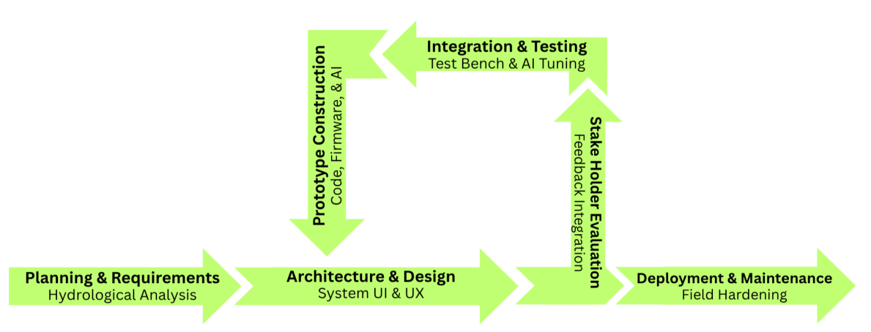

Cost Benefit Analysis
This cost and benefit analysis represents the process used by the project team to evaluate the advantages of deploying the proposed Smart Flood: Flood Monitoring and Early Warning System for Lower Antipolo, weighing the measurable socio-economic and operational benefits such as reduced municipal flood damages, enhanced disaster response efficiency, and extended civilian evacuation lead times against the direct capital and operational costs incurred during the hardware prototyping, cloud software deployment, and field maintenance of the system over a 5-year operational lifecycle using the standard financial metrics: Net Present Value (NPV) and Benefit-Cost Ratio (BCR).

Table 1
Cost and Benefits Analysis
Cost
Cost Category | Year 0 (Development) | Year 1 | Year 2 | Year 3 | Year 4 | Year 5
Initial Investment
Software & License | 20,000.00 | -- | -- | -- | -- | --
Hardware | 100,000.00 | -- | -- | -- | -- | --
Development Team | 90,000.00 | -- | -- | -- | -- | --
Testing | 60,000.00 | -- | -- | -- | -- | --
System's Setup | 30,000.00 | -- | -- | -- | -- | --
Workstations (Desktop & Laptop Computers | 100,000.00 | -- | -- | -- | -- | --
Recurring Costs
Maintenance & Support |  | 30,000.00 | 30,100.00 | 30,000.00 | 30,000.00 | 30,000.00
Training |  | 5,000.00 | 5,000.00 | 5,000.00 | 5,000.00 | 5,000.00
Addons (Security) |  | 37,308.00 | 37,308.00 | 37,308.00 | 37,308.00 | 37,308.00
Total Cost | 400,000.00 | 72,308.00 | 72,408.00 | 72,308.00 | 72,308.00 | 72,308.00

Benefit
Benefit Category | Year 1 | Year 2 | Year 3 | Year 4 | Year 5
Labor Cost Savings | 160,000.00 | 160,000.00 | 160,000.00 | 160,000.00 | 160,000.00
Reduced Printing | 25,000.00 | 25,000.00 | 25,000.00 | 25,000.00 | 25,000.00
Reduced Errors | 20,000.00 | 20,000.00 | 20,000.00 | 20,000.00 | 20,000.00
Total | 205,000.00 | 205,000.00 | 205,000.00 | 205,000.00 | 205,000.00

Benefit Cost Ratio
BCR= | 777,111.29 | 1.15
BCR= | 674,186.85 | 1.15
Metric | Result | Decision Rule (for Project Acceptance) | Conclusion
Benefit Cost Ratio (BCR) | 1.15 | BCR > 1 | Accepted
Summary CBA
Cost/Benefit Category | Year 0 | Year 1 | Year 2 | Year 3 | Year 4 | Year 5 | Total
Cost | 740,000.00 | 50,308.00 | 50,308.00 | 50,308.00 | 50,308.00 | 50,308.00 | 991,540.00
Benefit |  | 345,000.00 | 345,000.00 | 345,000.00 | 345,000.00 | 345,000.00 | 1,725,000.00
Return on Investment |  | 14.8% | 14.8% | 14.8% | 14.8% | 14.8%

Total Cost | 991,540.00
Total Benefit | 1,725,000.00
Total ROI | 74%
Annual ROI | 14.8%
Number of Years | 5 Years

The Cost-Benefit Analysis (CBA) conducted for this study evaluated the financial viability of the proposed system over a five-year period, incorporating an initial investment in Year 0 followed by recurring operational costs and benefits from Year 1 to Year 5. The total cost of the project, comprising software and licensing, hardware, development, testing, system setup, and ongoing maintenance and training, amounted to ₱991,540.00, with the majority (₱740,000.00) incurred as an upfront investment in Year 0. When discounted to present value, the total cost was computed at ₱674,186.85.
On the benefit side, the system is projected to generate ₱1,725,000.00 in total benefits over the same period, driven primarily by labor cost savings from operational efficiencies, along with reductions in printing and error-related expenses. The present value of these benefits was calculated at ₱777,111.29. Comparing these figures yielded a Benefit-Cost Ratio (BCR) of 1.15, which, since it exceeds the acceptance threshold of 1.0, indicates that the project is financially viable and is expected to generate more value than it costs to implement. Furthermore, the analysis showed a Total Return on Investment (ROI) of 74% and an Annual ROI of 14.8%, suggesting that the system is capable of recovering its costs and yielding a positive net return within the five-year horizon. Taken together, these results support the conclusion that the proposed system represents a sound investment, offering measurable financial returns primarily through improved operational efficiency and reduced recurring expenditures.

Architectural Design

Figure 2
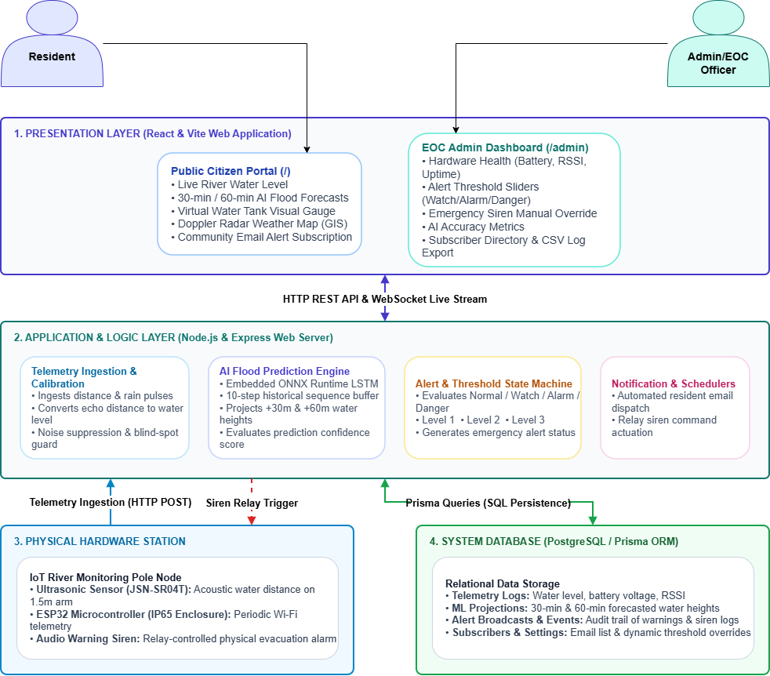
Smart Flood Architecture Diagram

The presentation layer, built with React and Vite, is organized into two role-based portals. The Public Citizen Portal provides community residents with a color-coded flood status banner, a virtual water tank visualization, AI-generated thirty- and sixty-minute forecast horizons, historical telemetry trendlines, a Doppler radar weather map, and an email subscription form, all accessible without authentication. The EOC Admin Command Center, protected behind token-based authentication, gives CDRRMO and BDRRMC operators hardware health diagnostics, threshold calibration sliders, a manual siren override with an automatic safety cutoff, live AI accuracy metrics, and subscriber and log management tools.
The application and logic layer, running on Node.js and Express, functions as the platform’s computational core. It ingests telemetry transmitted from the edge station, calibrates raw acoustic readings into water level values, and executes an embedded LSTM inference pipeline to generate the thirty- and sixty-minute forecast horizons. A multi-tier threshold state machine continuously evaluates incoming readings against configurable safety stages, namely Normal, Level 1 (Advisory), Level 2 (Warning), and Level 3 (Danger), dispatching email advisory notifications from Level 1 onward and triggering the siren relay at Level 2 and above as conditions escalate. This layer also runs background schedulers for meteorological polling and data retention, and communicates with clients through both a REST API for stateless requests and a WebSocket server for real-time, sub-second telemetry broadcasting
The physical hardware station, mounted along the riverbank, consists of an ESP32 microcontroller housed in an IP65 enclosure, interfaced with a cantilever-mounted JSN-SR04T ultrasonic sensor and a relay-actuated audio siren. This station samples environmental conditions continuously and transmits packaged JSON telemetry to the application layer over HTTP.
The system database layer, built on PostgreSQL and accessed through Prisma ORM, persists telemetry logs, AI projections, alert and system event records, subscriber and email dispatch logs, and configurable system settings, ensuring that all historical data and threshold calibrations survive server restarts. Together, these four tiers form a continuous functional pipeline: sensors capture environmental data, the ESP32 transmits it to the server, the server calibrates and evaluates the reading while generating AI forecasts, the result is persisted to the database and broadcast live to all connected dashboards, and, when a threshold is breached, the system simultaneously triggers the physical siren and dispatches emergency email alerts to subscribed residents.

Dataflow Diagram

Figure 3
Dataflow Diagram (Context Level 0)
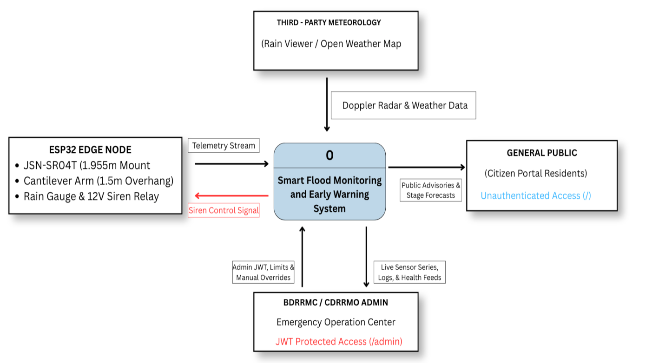
The ESP32 Edge Node, represents the physical cyber-physical hardware layer of the system, comprising the JSN-SR04T ultrasonic sensor mounted at a design clearance (Hmount) of at least 2.40 meters, the 1.5-meter cantilever arm, and the 12V siren relay. This entity supplies the system with a continuous Telemetry Stream, carrying raw water level and device health data into the central process for ingestion and evaluation. The relationship between this entity and the system is bidirectional, since the central process also issues a Siren Control Signal back to the edge node, instructing the physical relay to activate or deactivate the acoustic alarm based on either locally evaluated thresholds or remote administrative commands.
The Third-Party Meteorology entity represents external data sources such as RainViewer and OpenWeatherMap. This entity feeds Doppler Radar and Weather Data into the system as a one-directional input, supplementing the system's own sensor readings with broader regional weather context that is later displayed to users as part of the interactive radar and satellite overlays.
General Public entity represents community residents accessing the system through the unauthenticated Public Citizen Portal. The system delivers Public Advisories and Stage Forecasts to this entity, encompassing the color-coded alert banners, real-time water level readings, and AI-generated projections made available without requiring any login credentials, consistent with the zero-login architecture described elsewhere in this study.
BDRRMC/CDRRMO Admin entity represents disaster response personnel operating through the JWT-protected Admin and Emergency Operations Center Command Center. This relationship is bidirectional and carries the most privileged data flows in the diagram. The system transmits Live Sensor Series, Logs, and Health Feeds to the admin entity, providing dispatchers with the detailed telemetry, historical charts, and hardware diagnostics needed for operational decision-making. In return, the admin entity sends Admin JWT, Limits, and Manual Overrides into the system, representing authenticated threshold adjustments, manual siren commands, and other privileged administrative actions that only verified operators are permitted to issue.

Figure 4
Smart Flood DFD Context Level 1 Diagram
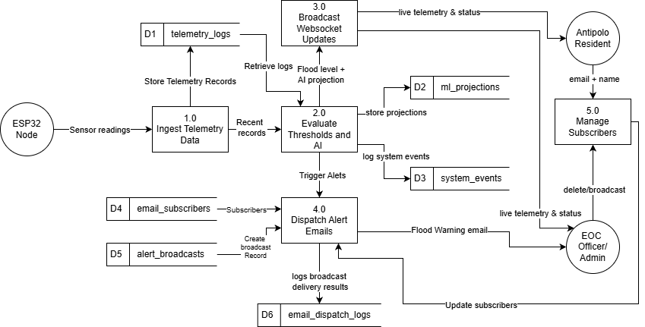
Process 1.0 forwards only the Recent Records onward to Process 2.0, Evaluate Thresholds and AI, establishing a clear separation between the ingestion of data and its interpretation.
Process 2.0 functions as the analytical core of the system. It retrieves historical readings from D1 to provide the sliding-window context required by the predictive model, then performs two parallel functions: evaluating incoming readings against configured flood thresholds, and executing the LSTM inference pipeline to generate thirty- and sixty-minute forecasts. The resulting predictions are written to D2, the ml_projections data store, while any threshold breaches, siren activations, or state transitions are logged to D3, the system_events data store, preserving an auditable history of significant system occurrences. From this evaluation, two outputs proceed downstream: a combined Flood Level and AI Projection payload is passed to Process 3.0, and a Trigger Alerts signal is passed to Process 4.0 whenever conditions warrant dissemination.
Process 3.0, Broadcast Websocket Updates, is responsible for real-time distribution. It takes the flood level and projection data from Process 2.0 and pushes Live Telemetry and Status updates simultaneously to both the Antipolo Resident entity, through the public-facing WebSocket connection, and the EOC Officer/Admin entity, through the authenticated administrative dashboard. This shared broadcast mechanism ensures that both user tiers observe the same underlying system state at the same moment, differing only in how that data is subsequently presented to each audience.
Process 4.0, Dispatch Alert Emails, handles asynchronous notification delivery when Process 2.0 signals a Trigger Alert. It draws its recipient list from D4, the email_subscribers data store, creates a corresponding broadcast record in D5, the alert_broadcasts data store, and issues Flood Warning email notifications to the appropriate recipients. Following transmission, delivery outcomes are logged to D6, the email_dispatch_logs data store, allowing the system to track whether each notification was successfully sent, providing an audit trail distinct from the general system event log maintained by Process 2.0.
Process 5.0, Manage Subscribers, governs the lifecycle of community subscriptions. The Antipolo Resident entity supplies an Email and Name directly to this process to register for alerts, which this process presumably persists to D4. The EOC Officer/Admin entity maintains authority over this process as well, issuing Delete and Broadcast commands to remove subscribers or trigger manual bulletins outside the automated alert pipeline. A final feedback loop closes the diagram, in which the EOC Officer/Admin sends an Update Subscribers flow back into Process 4.0, ensuring that any administrative changes made through Process 5.0 are reflected the next time alert emails are dispatched.

System Flowchart

Figure 5
System Flowchart for Smart Flood: Flood Monitoring and Early Warning System - Login and Authentication
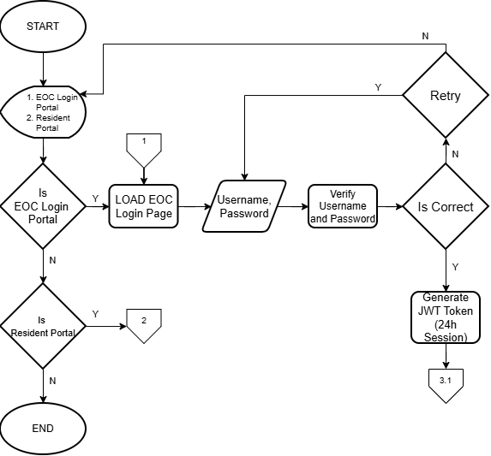

Figure 6
Public Resident View
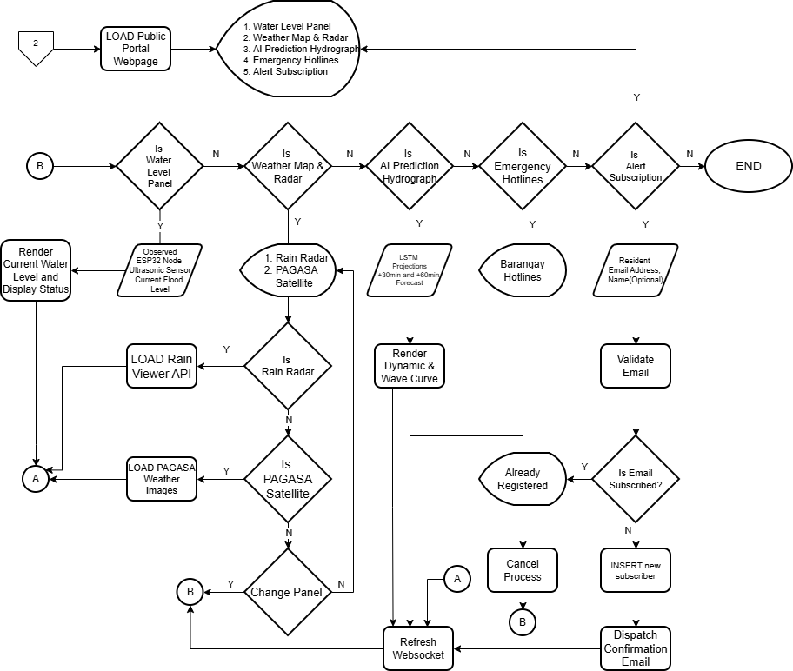

Figure 7
EOC Officer / Admin View Part 1
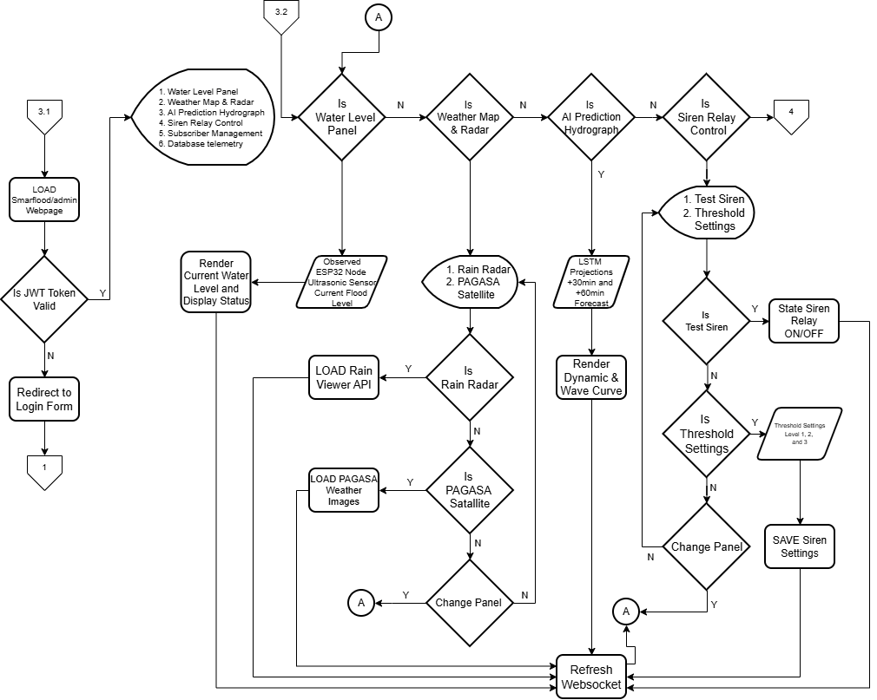

Figure 8
EOC Officer / Admin View Part 2
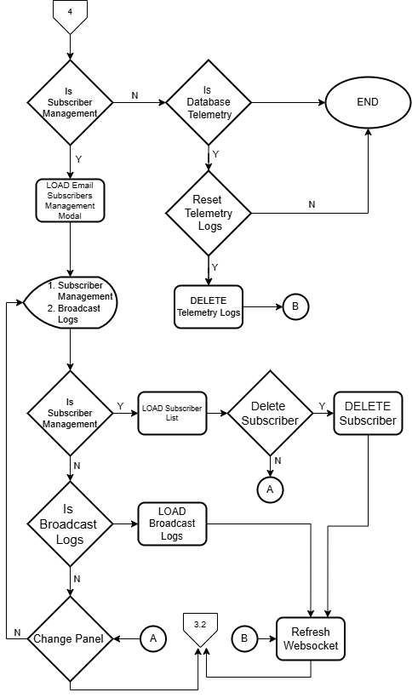

Figure 9
ESP32 Node
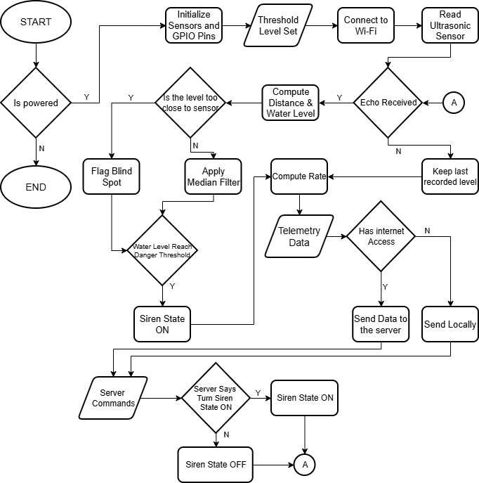

Site Map

Figure 10
Site Map for Smart Flood: Flood Monitoring and Early Warning System
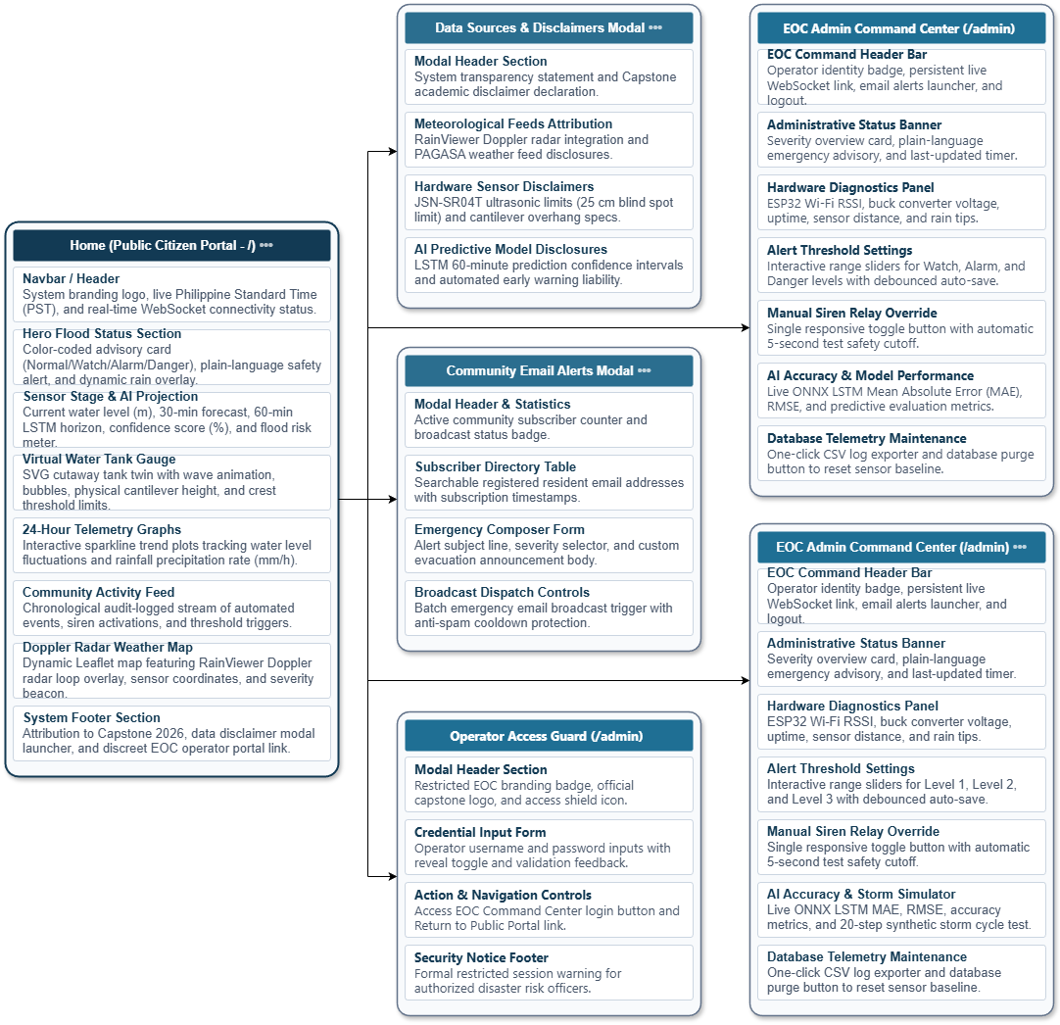
The Home page itself is composed of eight sequential sections that together constitute the resident-facing dashboard. The Navbar and Header establish the system's branding, display live Philippine Standard Time, and indicate real-time WebSocket connectivity status, giving the user an immediate signal of whether the data on screen is current. Beneath this, the Hero Flood Status Section presents the color-coded status card corresponding to the system’s four alert states (Normal and Levels 1 to 3), accompanied by a plain-language safety message and a dynamic rain overlay that visually reflects current precipitation intensity. The Sensor Stage and AI Projection section follows, surfacing the current measured water level alongside the thirty- and sixty-minute LSTM forecast horizons, their associated confidence scores, and an overall flood risk meter. The Virtual Water Tank Gauge renders an SVG cutaway visualization of the physical sensor installation, reflecting the actual cantilever mounting height and crest threshold limits so that residents can intuitively relate the abstract water level figure to the real structure over the creek. The remaining sections, namely the twenty-four-hour telemetry graphs, the community activity feed, the Doppler radar weather map, and the system footer, provide historical trend visibility, a transparent log of automated system events, external meteorological context, and academic attribution respectively, with the footer additionally containing the discreet entry point into the administrative side of the platform.
From this root page, four distinct branches extend downward, each serving a separate functional purpose. The first branch, Operator Access Guard, represents the authentication gate at the /admin route, and is intentionally minimal in scope, containing only a restricted header, a credential input form with a password reveal toggle and shake feedback on invalid attempts, and navigation controls to either proceed into the command center or return to the public portal. This branch exists as a distinct node in the hierarchy rather than being folded into the Command Center itself, reflecting the system's separation between the act of authenticating and the authenticated interface that follows.
The second branch, the EOC Admin Command Center, represents the authenticated /admin route accessible only after the Operator Access Guard has issued a valid session, and contains the full operational toolkit used by CDRRMO and BDRRMC personnel. This includes the command header bar and administrative status banner, which orient the operator upon login; the hardware diagnostics panel, which surfaces ESP32 Wi-Fi signal strength, buck converter voltage, uptime, and sensor distance readings for equipment health monitoring; the alert threshold settings, which allow interactive adjustment of the three flood severity levels through debounced auto-saving sliders; the manual siren relay override, which includes a default five-second acoustic relay test with a configurable duration capped at thirty seconds, preventing prolonged unintended activation; the AI accuracy, which exposes live ONNX model error metrics and a twenty-step synthetic storm cycle for validation without requiring an actual flood event; and the database telemetry maintenance section, which provides CSV export and database purge utilities for records management.
The third branch, the Community Email Alerts Modal, is a subscriber management interface nested within the administrative side of the platform, allowing EOC personnel to view subscriber statistics and a searchable directory of registered resident emails, compose emergency broadcast messages with a severity selector, and dispatch batch alert emails, with anti-spam cooldown protection preventing repeated notifications from being sent for the same event in rapid succession. The fourth branch, the Data Sources and Disclaimers Modal, functions as a transparency and academic disclosure panel accessible from the public portal, documenting the system’s reliance on third-party meteorological feeds such as RainViewer and OpenWeatherMap, the physical and operational limitations of the JSN-SR04T sensor including its twenty-five centimeter blind spot, and the confidence limitations inherent to the LSTM predictive model's sixty-minute forecast horizon.

Database Schema
Figure 11
Database Schema for Smart Flood: Flood Monitoring
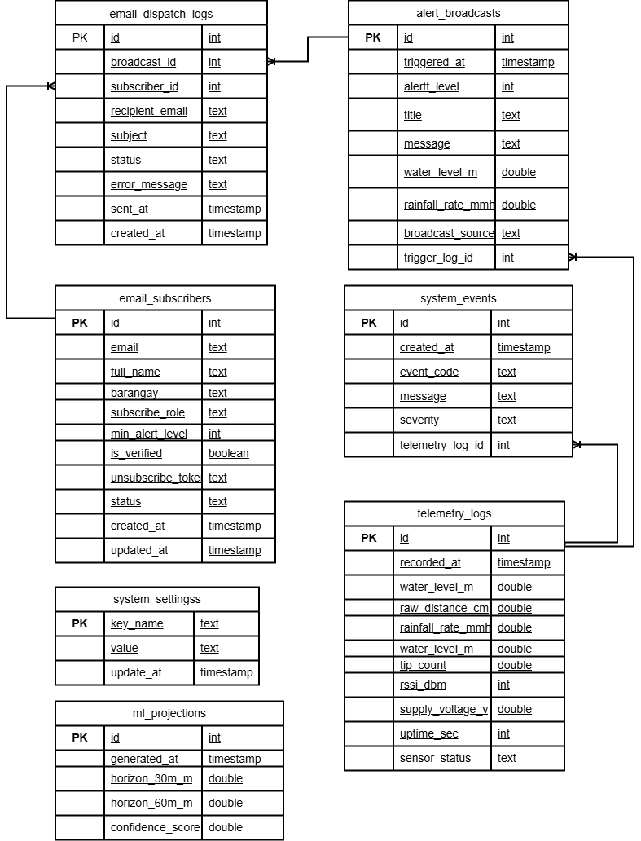

Wiring Diagram

Figure 12
ESP32 and Ultrasonic Sensor Wiring Diagram
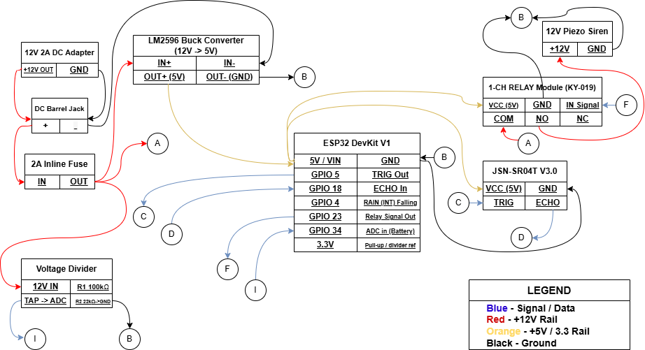

Technical Specification
The project team used the Arduino IDE to program and flash the edge microcontroller firmware in C++/Arduino, with Visual Studio Code as the primary IDE for full-stack development. The frontend is a React 19 single-page application styled with Tailwind CSS, using Leaflet.js for GIS mapping and Recharts for time-series charts. The backend runs on Node.js (LTS) with Express.js, handling REST endpoints, CORS policies, JWT-based admin authentication, and a WebSocket server for real-time telemetry. Email alerts are sent through Nodemailer over authenticated SMTP, while weather data is pulled from the RainViewer and OpenWeatherMap APIs. Data is stored in a cloud-hosted PostgreSQL database via Supabase, managed through Prisma ORM. Machine learning inference runs directly in Node.js using ONNX Runtime, executing a 2-layer LSTM model trained in PyTorch and exported to ONNX with its normalization scaler parameters. Development and testing were done on 64-bit Windows 11.
The LSTM model operates on a sliding window of 6 timesteps at 10-minute intervals (60 minutes of historical context), producing dual-output predictions at 30 and 60 minutes ahead. The model was evaluated on a held-out synthetic hydrograph test set using two input features: water-level (m) and water-level surge rate (m/h). At the 30-minute horizon, the model achieved a Mean Absolute Error (MAE) of 0.0153 m, Root Mean Square Error (RMSE) of 0.0191 m, and a Nash-Sutcliffe Efficiency (NSE / R²) of 0.826 — indicating strong predictive skill. At the 60-minute horizon, MAE was 0.0224 m, RMSE was 0.0279 m, and NSE was 0.629, reflecting acceptable accuracy at the outer forecast bound.
The river station’s hardware was designed around an ESP32 DevKit V1 microcontroller with a dual-core Xtensa LX6 processor (up to 240 MHz) and built-in Wi-Fi. Water level was specified to be measured via a JSN-SR04T V3.0 waterproof ultrasonic sensor, with a voltage divider stepping its 5V echo signal down to the ESP32’s 3.3V logic level. The sensor was designed to be mounted on a 1.5-meter cantilever arm with a 45 mm bracket drop, at a clearance of at least 2.40 m above the riverbed, to aim the acoustic beam over open water and avoid interference from the pole. A 12V piezoelectric siren, driven by an optocoupled relay, was specified to provide on-site audible alerts. Power was specified to come from a 12V source, stepped down to 5V via an LM2596 buck converter, protected by a 2A fuse, and monitored through a voltage divider feeding an ADC pin for battery health. All electronics were designed to be housed in an IP65 waterproof enclosure mounted on a pole, with pole height to be set by the site survey so that the sensor face sits at least 2.40 m above the riverbed.
For EOC deployment, the recommended setup is 64-bit Windows 10/11 (or equivalent Linux/macOS) with a 1920×1080 display to properly render dashboards, gauges, charts, and radar maps. A stable connection with at least Wi-Fi 5 or Gigabit Ethernet is needed for real-time WebSocket streaming, using Chrome 120+, Edge 120+, or Firefox 121+. The firmware was designed to store the Level 2 and Level 3 thresholds in non-volatile memory, synchronize them from the server when connectivity is available, and activate the siren relay locally when a reading meets or exceeds Level 2, regardless of server or network status.
For residents accessing the citizen portal on mobile, Android 11+ or iOS 16.4+ is recommended, along with a 4G/5G or Wi-Fi connection for real-time updates. Supported browsers include Chrome for Android 120+, Safari Mobile 17+, or Samsung Internet 24+, with JavaScript and WebSockets enabled for background telemetry and alerts.

System Testing/ Evaluation
User Acceptance Testing is included because functional correctness alone does not guarantee that a system will actually be trusted and used by the people it is built for, especially in a disaster warning context where CDRRMO officers and residents are largely non-technical stakeholders whose adoption depends on clarity and perceived value rather than code quality. The Technology Acceptance Model is adopted as the theoretical basis for this evaluation because it is a widely validated framework for predicting technology adoption through two core constructs. Perceived Usefulness refers to the degree to which a user believes the system improves their ability to perform a relevant task, such as a dispatcher's ability to monitor and respond to flood risk, or a resident's ability to receive timely warnings and act on them. Perceived Ease of Use refers to the degree to which a user believes the system is simple and effortless to operate, which matters greatly for both the technical Admin/EOC dashboard and the non-technical Public Citizen Portal. Together, these two constructs shape the user's overall attitude toward the system and their intention to continue using it, making TAM an appropriate lens for measuring genuine adoption readiness rather than surface-level satisfaction.

Table 2
Likert Scale
Rating | Interpretation | Description | Mean Score
5 | Highly Acceptable | Exceeds Expectations | 4.21 to 5.00
4 | Acceptable | Meets Expectations | 3.41 to 4.20
3 | Neutral | Acceptable, but has room for improvement | 2.61 to 3.40
2 | Not Acceptable | Fails to meet expectations | 1.81 to 2.60
1 | Highly Not Acceptable | Unacceptable | 1.00 to 1.80

Locale of the Project
The study is conducted in the low-lying, flood-vulnerable waterways and riparian corridors of Lower Antipolo, Rizal, Philippines. The intended deployment and monitoring sites encompass critical drainage choke points and bridge crossings: Quiling Creek, Payagwan Bridge and Binayoyo Bridge.
Topographically, Lower Antipolo serves as an immediate receiving basin for stormwater runoff originating from the upper Antipolo foothills and the upper Marikina watershed. These waterways exhibit a normal dry-season baseline depth of approximately 1.0 m, but experience rapid hydrological surge during heavy monsoonal rains and tropical cyclones, spilling over riverbanks and inundating adjacent roadways and residential settlements at a stage height of approximately 2.0 m. The physical hardware installation was designed to be situated directly on bridge structures and retaining walls over the stream channel:
The JSN-SR04T waterproof ultrasonic transducer is positioned downward at the terminal point of a 1.5 m horizontal cantilever arm (45 mm bracket drop). In accordance with CDRRMO guidance, obtained through an email interview, that the installation must be located above the 2.0 m spill stage, the sensor face is mounted at a design clearance of Hmount ≥ 2.40 m above the riverbed, which accounts for the spill stage (2.00 m), the sensor’s 0.25 m minimum sensing distance, and a 0.15 m safety margin. The final Hmount is to be confirmed through an on-site elevation survey.
The control enclosure (IP65 junction box) and 12V high-decibel piezoelectric siren are secured to the bridge pier and mounting pole, projecting audible warnings toward adjacent low-lying communities.

Subject of the Project
Community Residents of Lower Antipolo: Vulnerable riverside households in the immediate vicinity of Quiling Creek, Payagwan Bridge, and Binayoyo Bridge. These end users interact with the unauthenticated Public Citizen Portal ( / ) to access visual alert banners (Normal, Advisory, Warning, Danger), real-time water levels, plain-language AI forecast summaries, Doppler radar overlays, emergency hotlines, and emails.
Disaster Management Operators: Personnel and dispatchers from the Antipolo City Disaster Risk Reduction and Management Office (CDRRMO) and the Barangay Disaster Risk Reduction and Management Committees (BDRRMC). As primary operational evaluators, they utilize the authenticated Admin / EOC Command Center ( /admin ) for full sensor telemetry, battery/RSSI health monitoring, dynamic threshold configuration, manual siren controls, and CSV log exports.

System and Technical Subject Matter
The cyber-physical edge monitoring unit, consisting of an ESP32 DevKit V1, JSN-SR04T ultrasonic transducer, optocoupled relay, and 12V piezoelectric siren.
The cloud infrastructure and predictive engine, encompassing a Node.js/Express backend hosted on Render, a decoupled 3NF PostgreSQL database via Supabase/Prisma ORM, and an embedded 2-layer Long Short-Term Memory (LSTM) neural network executing in ONNX Runtime (flood_lstm.onnx) to produce localized 30- and 60-minute surge forecasts.
Ethical Considerations
The deployment, data gathering, and field validation of the early warning system follow established ethical research protocols, legal mandates, and safety standards. Because audible sirens can cause unnecessary panic or warning fatigue in densely populated riverbank communities, all siren testing is tightly controlled. Bench testing is done during daytime hours using muted software flags or low-voltage checks, while live field alerts are restricted to verified Level 2 (Warning) and Level 3 (Danger) conditions in line with CDRRMO acoustic guidelines. A five-second automatic safety cutoff also prevents prolonged or accidental siren activation.
Before installing any hardware on public bridges, river walls, or drainage easements, the team secured formal clearances from the Antipolo City Mayor's Office, the City Engineering Office, the Antipolo CDRRMO, and the relevant Barangay Councils, including Barangay Mayamot, to ensure the equipment doesn't interfere with waterway hydraulics or existing flood infrastructure.
In compliance with the Data Privacy Act of 2012 (RA 10173), the public portal requires no login or personal information to view river data, predictions, or radar maps. Residents who opt in for alerts only provide an email address and barangay, with no sensitive personal data collected. Subscriber records are securely stored and used only for emergency broadcasts, and each subscriber receives a unique unsubscribe token for immediate opt-out at any time.
All participants in the system evaluation and usability surveys were designed to be briefed on the study’s purpose and to give written informed consent, with a clear right to withdraw at any time without consequence.
Sensor logs and model performance metrics (MAE, RMSE, NSE) are reported transparently and without alteration, and system limitations, such as sensor blind spots, forecast divergence during rapid water recession, and occasional network dropouts, are disclosed openly to support academic integrity and reproducibility.
The team coordinated with the Antipolo CDRRMO on site requirements. Formal written endorsements and clearances from the Antipolo City Mayor’s Office, City Engineering Office, and concerned Barangay Councils are required before any permanent installation on public bridges, retaining walls, or municipal easements, and had not been secured at the time of writing. The system was therefore evaluated through software simulation, and installation is recommended only after these clearances are obtained.

Procedures of the Project
The research study follows four systematic procedural phases, proceeding sequentially from planning through evaluation, with each phase's outputs serving as the entry criteria for the next.
Site Inspection and Permitting. Formal transmittal letters and validation guides will be submitted to the Antipolo CDRRMO and concerned barangay offices. Necessary municipal clearances are required to conduct field measurements and mount equipment at Quiling Creek, Payagwan Bridge, and Binayoyo Bridge.
Datum and Threshold Calibration. Physical elevation surveys will measure the bridge-to-riverbed clearance to confirm Hmount ≥ 2.40 m. Water level is computed as Hmount minus the measured sensor distance, so the maximum measurable stage is Hmount − 0.25 m. Default operational thresholds are aligned with Antipolo CDRRMO spill height and remain adjustable: Level 1 Advisory (≥ 1.20 m), Level 2 Warning (≥ 1.60 m), and Level 3 Danger (≥ 2.00 m).
The web-platform procedures below were carried out during the study; the hardware procedures were planned and are to be carried out prior to field deployment.
Edge Node Assembly. The ESP32 microcontroller, JSN-SR04T sensor, optocoupled relay, 12V siren, and LM2596 buck converter are assembled in an IP65 waterproof junction box with inline fuse protection (2A).
Firmware Flashing. The SmartFlood_ESP32.ino firmware was designed to be uploaded via Arduino IDE, establishing rolling-median distance filters, JSON serialization, and an offline fail-safe routine for autonomous siren triggering. The firmware was also designed to classify a reading below 0.30 m, or an echo timeout during a rising water trend, as Level 3 (Danger).
Cloud and AI Pipeline Setup. The Node.js/Express backend is deployed to Render, connecting to Supabase (PostgreSQL via Prisma ORM). The 2-layer LSTM model (flood_lstm.onnx) is loaded into memory using onnxruntime-node alongside scaler_params.json for live inference.
Frontend Deployment. The dual-interface React + Vite application is deployed to Vercel, establishing native WebSocket listeners for real-time telemetry streaming and route guards securing /admin.
Bench Testing. The assembled edge device is verified using controlled test stands (adjusting water targets from 20 cm to 180 cm manually) to verify telemetry transmission (POST /api/v1/telemetry), database logging, and automated relay clicks.
Hydrological Simulation Benchmark. The end-to-end cloud pipeline is validated using tools/virtual-esp32.js, streaming synthetic typhoon hydrographs through the system to measure LSTM prediction accuracy (+30 m / +60 m) and evaluate automated siren and email notification transitions.
Controlled Field Trial. The physical prototype is temporarily rigged at the designated bridge site (e.g., Payagwan or Quiling Bridge) to capture live environmental stage variations and precipitation pulses during local weather events.
User Acceptance and Performance Evaluation. CDRRMO dispatchers and local community representatives interact with the platform under simulated and live storm conditions. System usability, interface clarity, and alert effectiveness are formally measured using standard evaluation instruments (e.g., ISO/IEC 25010 and Technology Acceptance Model surveys).
Data Analysis and Manuscript Finalization. Telemetry logs, latency metrics, and survey results are compiled, analyzed statistically, and documented in Chapters 4 and 5 of the capstone manuscript.

REFERENCES
Abalos, M. S., & Fajardo, A. C. (2023). IoT based flood detection, alarm and monitoring system using multilayer perceptron and regression. International Journal of Multidisciplinary Research and Analysis, 6(7), 3041–3047. https://doi.org/10.47191/ijmra/v6-i7-16
Agyei, V., Ahadzie, D. K., & Peprah, C. (2021). Multi-criteria analysis of early warning system for flood risk reduction in Barangay Tumana in Marikina City, Philippines. Journal of Science and Technology (Ghana), 38(1,2&3), 66–80.
Al Haris, F. H. S., Wisudawanto, R., & Fathin Wahyu Lestari, A. (2025). Rancang bangun sistem IoT berbasis energi hibrid untuk pemantauan real-time dan peringatan dini banjir rob pesisir [Design and construction of a hybrid energy-based IoT system for real-time monitoring and early warning of coastal rob flooding]. Jurnal Algoritma, 22(2), 2215–2224. https://doi.org/10.33364/algoritma/v.22-2.2948
Arante, H. R. C., Sybingco, E., Roque, M. A., Ambata, L., Chua, A., & Gutierrez, A. N. (2025). Development of a secured IoT-based flood monitoring and forecasting system using genetic-algorithm-based neuro-fuzzy network. Sensors, 25(13), 3885. https://doi.org/10.3390/s25133885
Beck, K., Beedle, M., van Bennekum, A., Cockburn, A., Cunningham, W., Fowler, M., Grenning, J., Highsmith, J., Hunt, A., Jeffries, R., Kern, J., Marick, B., Martin, R. C., Mellor, S., Schwaber, K., Sutherland, J., & Thomas, D. (2001). Manifesto for agile software development. Agile Alliance. https://agilemanifesto.org/
Byaruhanga, N., Kibirige, D., Gokool, S., & Mkhonta, G. (2024). Evolution of flood prediction and forecasting models for flood early warning systems: A scoping review. Water, 16(13), 1763. https://doi.org/10.3390/w16131763
Canillo, R. G., & Hernandez, A. A. (2021). Data analytics and machine learning integration for a dynamic flood information visualization and prediction dashboard for Manila [Conference paper]. 2021 IEEE 17th International Colloquium on Signal Processing & Its Applications (CSPA). https://doi.org/10.1109/CSPA52141.2021.9377276
Cho, M., Kim, C., Jung, K., & Jung, H. (2022). Water level prediction model applying a long short-term memory (LSTM)–gated recurrent unit (GRU) method for flood prediction. Water, 14(14), 2221. https://doi.org/10.3390/w14142221
Crucillo, J. C., Lucero, J. B., Gelito, N. A., Medina, R. A., & Palconit, M. G. (2026). Fews: IoT-based flood early warning system for Barangay Doña Imelda, Quezon City. ResearchGate. https://www.researchgate.net/publication/400959572
Esposito, M., Palma, L., Belli, A., Sabbatini, L., & Pierleoni, P. (2022). Recent advances in Internet of Things solutions for early warning systems: A review. Sensors, 22(6), 2124. https://doi.org/10.3390/s22062124
GSM Association. (2022). Philippines early warning systems: Risk knowledge, forecasting, dissemination, and preparedness. GSMA Mobile for Development. https://www.gsma.com/solutions-and-impact/connectivity-for-good/mobile-for-development/wp-content/uploads/2022/06/PhilippinesEWS_R_Web.pdf
Kumar, A., Sarangi, A., Singh, D. K., Dash, S., & Mani, I. (2023). Evaluation of ultrasonic sensor for flow measurement in open channel. Journal of Scientific & Industrial Research, 82(10), 1091–1099. https://doi.org/10.56042/jsir.v82i10.4282
Mathushaharan, S. (2022). Design of a digital symmetric moving average filter for noise reduction in HC-SR04 ultrasonic distance sensor readings. International Journal of Innovative Science and Research Technology, 7(9). https://www.ijisrt.com/assets/upload/files/IJISRT22SEP795.pdf
Navarro, K. J., Reblando, A. M., Pandato, J. F., Villanueva, R. M., Dee, A. L., & Chua, A. Y. (2026). A modular LoRaWAN flood monitoring and prediction system using a DPS310 pressure sensor and support vector regression. HighTech Journal. https://hightechjournal.org/index.php/HIJ/article/view/1562
Nik Mohd Kamal, N. N. M. S., Zainuddin, A. A., Shamsudin, A. U., Sapuan, M. S., Samsudin, M. H. A., & Zulkfli, M. A. H. (2025). Development and implementation of an IoT-based early flood detection and monitoring system utilizing time series forecasting for real-time alerts in resource-constrained environments. Malaysian Journal of Science and Advanced Technology, 5(1), 1–10. https://doi.org/10.56532/mjsat.v5i1.370
Obaid, A. H. (2024). Using prototypes in agile software development. International Journal of Computers and Informatics, 3(2). https://doi.org/10.59992/IJCI.2024.v3n2p2
Organisation for Economic Co-operation and Development. (2025). Disaster early warning systems and private sector participation in ASEAN: Focus on the Philippines. https://www.researchgate.net/publication/403525164
Panganiban, C. H. (2022). Rainfall measurement and flood warning systems: A review. ResearchGate. https://www.researchgate.net/publication/363796595
Siddique, A., Ahmed, F., & Husain, S. (2023). IoT-based flood monitoring and early warning systems: A review. EAI Endorsed Transactions on Internet of Things. https://publications.eai.eu/index.php/IoT/article/view/2968
Te, M. C. L., Bautista, J. A. T., Dimacali, S. M. E. V., Lood, A. V. M., Pangan, M. G. M., & Chua, A. Y. (2024). A smart IoT urban flood monitoring system using a high-performance pressure sensor with LoRaWAN. HighTech and Innovation Journal, 5(4), 918–936. https://doi.org/10.28991/HIJ-2024-05-04-04
Tolentino, L. K. S., Baron, R. E., Blacer, C. A. C., Aliswag, J. M. D., De Guzman, D. C. E., Fronda, J. B. A., Valeriano, R. C., Quijano, J. F. C., Padilla, M. V. C., Madrigal, G. A. M., Valenzuela, I., & Fernandez, E. (2022). Real time flood detection, alarm and monitoring system using image processing and multiple linear regression. Journal of Computational Innovations and Engineering Applications, 7(1), 12–23. https://doi.org/10.2139/ssrn.4319789
Wandi, I. A., & Ashari, A. (2023). Monitoring ketinggian air dan curah hujan dalam early warning system bencana banjir berbasis IoT [Water level and rainfall monitoring in an IoT-based flood-disaster early warning system]. IJEIS (Indonesian Journal of Electronics and Instrumentation Systems), 13(1), 101–110. https://doi.org/10.22146/ijeis.83569
Zakaria, M. I., Jabbar, W. A., & Sulaiman, N. (2023). Development of a smart sensing unit for LoRaWAN-based IoT flood monitoring and warning system in catchment areas. Internet of Things and Cyber-Physical Systems, 3, 249–261. https://doaj.org/article/a8c9c658df9b420bac16ccf90a824d0f

APPENDICES

A. Gantt Chart of Activities
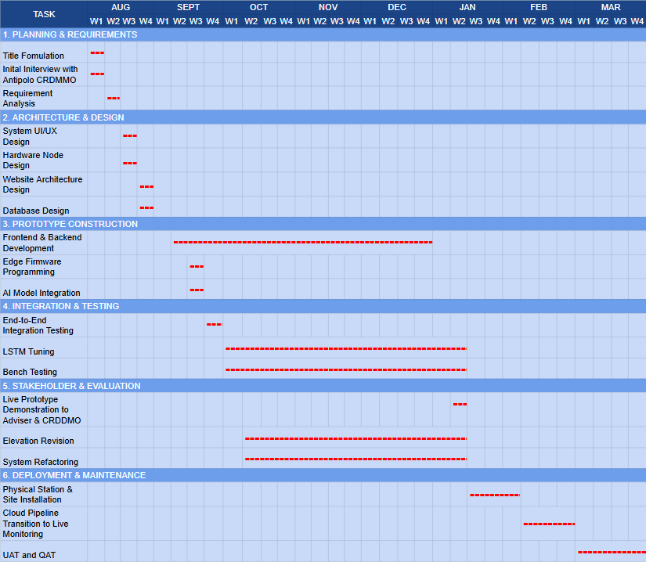

B. Approved Title Form D.2


